**<script> place**

<script> element is an Html element used to embedded JS codes inside it. We can place <script> elements in two positions:

1. Inside an HTML page :

You can place <script> in anywhere in the html page.

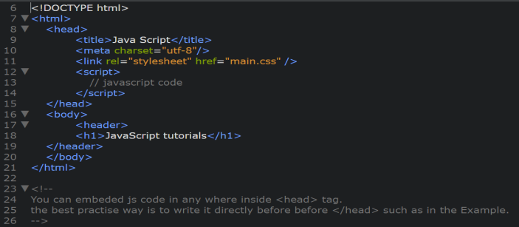 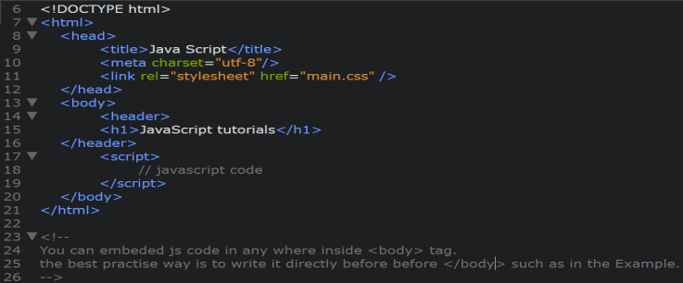

1. In an external JS file:

You can embed <script> in an external JS file and **linked** this file with an html page; again you can place <script> in anywhere in html document.

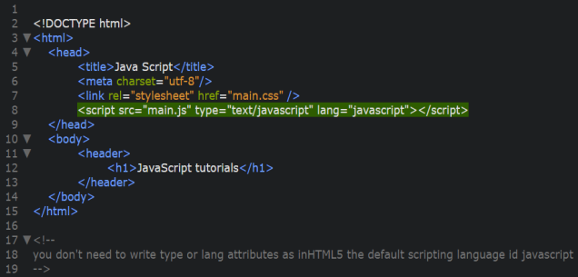 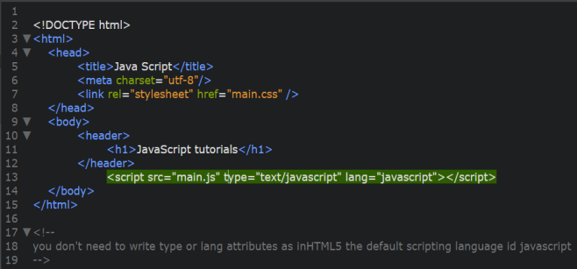

**Note:**

1. The **best practice** is to place <script>s before </body>
2. The **best practice** is to place JS codes in an external file.
3. You can add any number of <script>s (internal or external files) in one html page.
4. You can use both internal and external ways in one html page.
5. The script will behave as if it was located exactly where the <script> tag is located.
6. External scripts **cannot** contain <script> tags.
7. Placing scripts in external files has some advantages:
   * It separates HTML and code
   * It makes HTML and JavaScript easier to read and maintain
   * Cached JavaScript files can speed up page loads.
   * The browser will download JS file and store it in its cache memory. Other pages that reference the same script will take it from the cache instead of downloading it again, so the file is actually downloaded only once. That reduces traffic and makes pages faster.